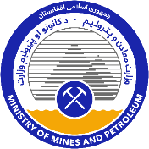
ISLAMIC REPUBLIC OF AFGHANISTAN
MINISTRY OF MINES AND PETROLEUM
TENDER FOR HERAT CEMENT
TENDER NOTICE

[8 July 2021]

Introduction and Project Description
Pursuant to Article 41(2) of the Minerals Law of 2018 published in Official Gazette No. 1315 dated 1398/07/21 (“Minerals Law”), the Ministry of Mines and Petroleum (“Ministry”), hereby announces this tender notice (“Tender Notice”) for the award of a Mining Concession in respect of Herat cement identified by the coordinates and plan in Annexure 1 to this Tender Notice (“Project”).
The Mining Concession will be a two-stage concession that provides for:
- the grant of an Exploration Licence authorizing exploration for limestone, clay and gypsum in respect of the Project; and
- subject to exploration results and a feasibility study, the right of priority to the grant of an Exploitation Licence authorizing mining and processing.
Details of the Project are included in Annexure 2 of this Tender Notice.
Further details about the Project can be found on the National Procurement Authority website (www.npa.gov.af), Ministry website (www.momp.gov.af), and other websites such as www.dgmarket.com.
Please note that capitalized terms not defined herein have the meanings given to them in the Minerals Law or the Mining Regulations 2019 published in Official Gazette No. (1366) dated 25 January 2020 (“Regulations”).

Expression of Interest and Pre-Qualification
Persons or entities who are interested in this opportunity should complete the Expression of Interest form that is attached to this Tender Notice as Annexure 3 no later than the date specified therein.
The Ministry has published a copy of the Pre-Qualification Questionnaire (“PQQ”) for the Project with this Tender Notice. Interested parties who submit the Expression of Interest form (“Prospective Bidders”) should complete the PQQ according to the instructions included therein and lodge the completed PQQ according to the directions below.
The PQQ must be completed in (i)] English [and (ii) either Dari or Pashto and submitted in hard and soft (e.g., delivered on a CD ROM or flash drive) copy contained in a sealed envelope to [Sayed Zabihullah Shadab], Directorate General of Large Scale Mines, Ministry of Mines and Petroleum, Charayi Abdulhaq (Abdulhaq Circle), Kabul, Afghanistan.
Responses to the PQQ will be due no later than 12 noon (Kabul Local Time) on [8 September 2021].
The Ministry will evaluate responses to the PQQ based on:
- satisfaction of all of the requirements described in the PQQ, including eligibility requirements;
- the technical expertise of the Prospective Bidder and key personnel associated with the Prospective Bidder to conduct exploration in respect of the Project (see Regulations, Article 11(2)1);
- the financial capacity of the Prospective Bidder to conduct exploration of the Project (see Regulations, Article 11(2)1);
- the experience of the Prospective Bidder and key personnel associated with the Prospective Bidder, in the successful delivery on commitments related to community development, local content, environmental management, and health and safety (see Regulations, Article 11(2)3); and
- intent to expend funds in exploration of the Project over the first three year term of the Exploration Licence in excess of one million US dollars (see Regulations, Article 11(2)4).

Tender Process
The Ministry will notify Prospective Bidders if they have qualified to participate in the tender process.
Qualified Prospective Bidders must submit a bid document fee to the Ministry in the amount of three hundred thousand (300,000) Afghan Afghani pursuant to Article 12(3) and Schedule 2 of the Regulations no later than 12 noon (Kabul Local Time) on [The date will be specified to the Qualified Bidders after PQQ Evaluation ].
Qualified Bidders will also be asked to sign a Non-Disclosure Agreement (which is set out in the PQQ).
Upon payment of the bid document fee and submission of an executed Non-Disclosure Agreement, the Ministry will issue a Request for Proposal (“RFP”) to such qualified Prospective Bidders.
Tender proposals in response to the RFP will be due no later than 12 noon (Kabul Local Time) on [30 October 2021].
A bid bond is required and the amount of such bid bond will be stated in the RFP. The bid bond shall be in the form of bonds or securities provided by an established bank or financial institution which is registered in accordance with applicable laws, and is acceptable to the Ministry. Subject to Article 17(3) of the Regulations and pursuant to Article 17(4) of the Regulations, the bid bond will be returned to the appropriate bidder within 10 working days of (i) execution of the Mining Concession by that bidder; (ii) execution of a Mining Concession by another bidder; or (iii) termination of the bidding process without award of a Mining Concession.
The bidding process for the Project will be administered by the Directorate General of Large Scale Mines, which is responsible for the administration of tendering processes for large scale mining projects in accordance with the Minerals Law and Regulations.

Annexure 1 – Project Area
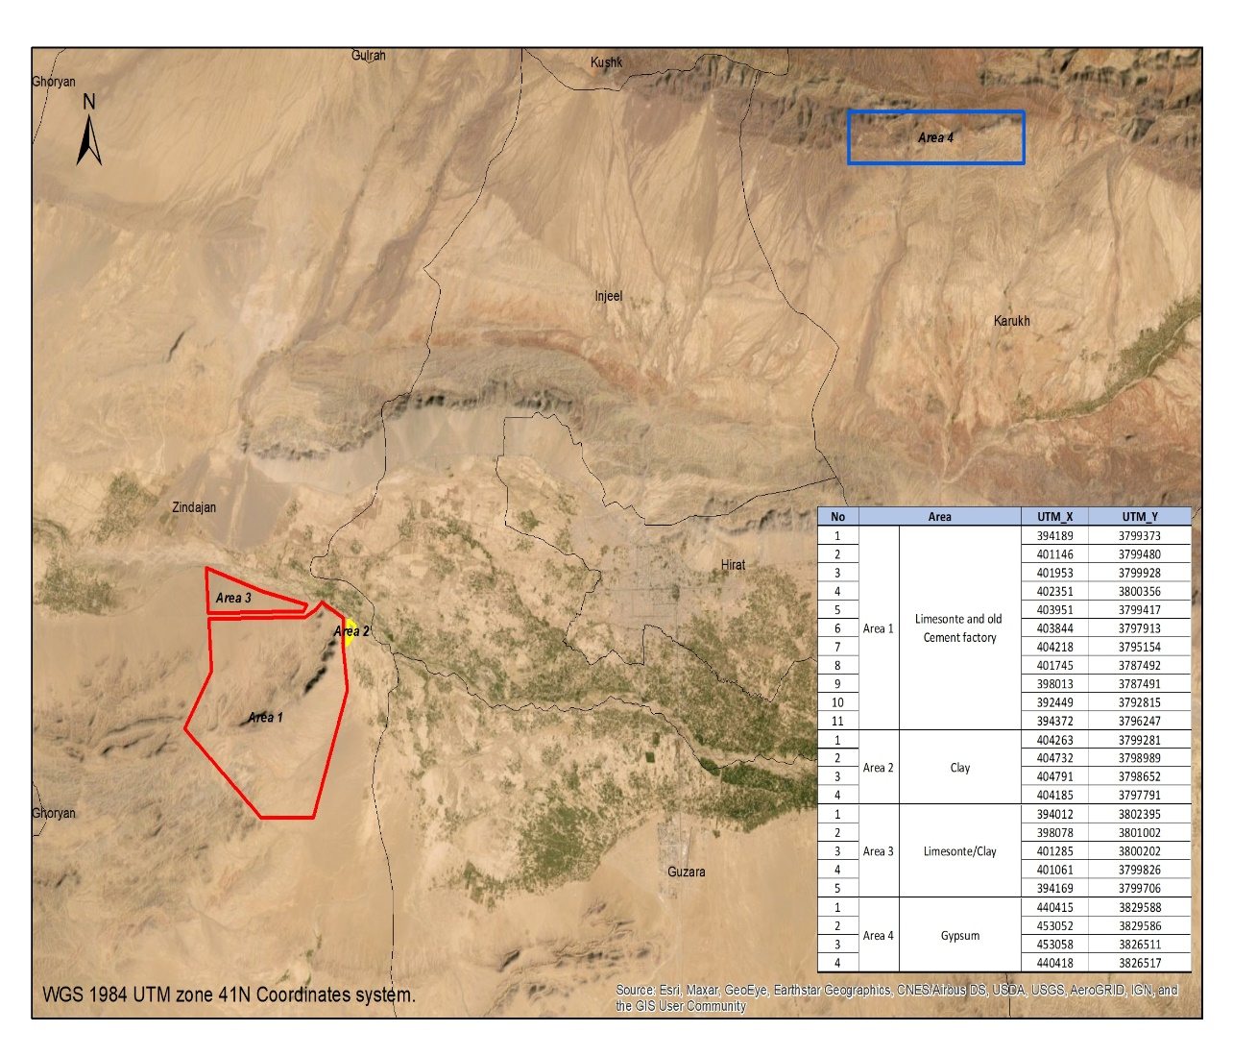

Annexure 2 - Project Description

The Herat cement area of interest (AOI) is located in western Afghanistan (Herat Province) about 25 km west of Herat City and about 100 km east of the Iranian border at elevations of about 850-1350 m. The potential plant area is situated on the southern side of the Hari River having easy linkage to the primary road connections. Additionally, a railway link from Herat City to Iran has just been opened and can serve the transport needs from Afghanistan to Turkey and Europe via Iranian ports. The Herat cement plant site is situated at the plateau near the Koh-i Kaftar mountain range dominated by the limestone suitable for cement production.
In order to replace the currently imported cement consumption by domestic production, the Government of the Islamic Republic of Afghanistan is undertaking a competitive tender for the award of a mining concession in respect of the Herat cement AOI for the exploration for and mining of limestone, clay and gypsum and the development and operation of a cement plant. At Herat, there is one of the four old and outdated cement plants in Afghanistan containing considerable development potential. This is due to its significant material resources needed for the cement production and convenient location close to the major Herat City. These necessary materials include quality limestone, clay and gypsum, all estimated to have enough resources close to the plant for long-term production. However, more detailed studies are needed to define the proven reserves.
Initially, the Herat cement factory was under construction in the mid-’70s using Czech financial and technical assistance to produce Portland 325 brand cement for seven south-western provinces. The plant was initially designed to produce 700 t/d, or 210,000 metric tons per year (t/a), using the wet blending process. The Soviet invasion stopped the construction works in 1979 and all technical equipment and machinery were damaged or destroyed.
In cement production the dominant materials, including limestone and clay known as kiln feed are grinded and heated in chemical reaction chamber in high temperature of 1400-1500 °C forming nodular material called clinker. The process requires lot of energy, and heating is typically done using coal, which may be available from the Sabzak coal mines located 140 km north of the Herat old plant site or from more close-by carbonaceous shale occurrences near Chartaq (Chahartak). In the final part of the process, the clinker is cooled and grinded into fine particles adding some gypsum to control the setting time of the cement. Gypsum occurs at different locations of Herat Province, and could be available from about 120 km west of Herat city in the Ghorian district or from Qol Seyah Abdeh Moghol mine in Karokh District. Also crucial for the overall development of the cement production, the Herat site can be easily connected to the electric network belonging to the Iranian grid. Gas and coal, which is available from relatively close-by mines in Afghanistan, offer interesting options as main energy source for the cement plant.
The area of the Herat cement old factory site is closely linked to one of 24 specific areas of interest (AOIs) with recognized economic potential as defined in the joint geologic activities from 2009 to 2011 between the Geological Survey of USA (USGS), the U.S. Department of Defense Task Force for Business and Stability Operations (TFBSO), the Ministry of Mines and Petroleum (MOMP) and Afghanistan Geological Survey (AGS). In this exercise, the extensive, freely downloadable GIS package was compiled and developed. The old geological data was complemented by new digital information including the modern satellite image interpretation techniques and other digital data sets. In more detail, the new data sets included the new Advanced Spaceborne Thermal Emission and Reflection (ASTER), radiometer Global Digital Elevation Map (GDEM) data, and other new datasets, including hydrographic databases, ASTER map-ping, hyperspectral data, geophysical data, and geohydrology data and interpretations. The final objective of the USGS surveys was to develop Mineral Bidding Packages of all AOIs. Even though the cement old factory area was delineated as a separate target in the USGS survey, it did not receive identical data processing as the other AOIs. The most detailed data originates actually from field surveys and is largely based on earlier reports by Russian and Czech experts made in the 1960s and 1970s and translated into English during the USGS collaboration about ten years ago. The field work comprised geological mapping in different scale from 1:50 000 for the complete site and some detail maps and cross-sections of individual places, as well as sampling and analyses of the different lithologic strata including limestone, marl and claystone. The material and their resources had been regarded in the past as suitable for cement making and initiated construction of a cement plant.
The final objective of the planned tendering is to locate an investor to develop the Herat cement factory into production and fill the current demand gap. This goal is favoured by extensive, nearby material resources and existing local need of cement that has been covered during the last decades mainly by import. In spite of the existing geological studies and resource calculation, more studies are needed to confirm the tonnage and composition of limestone and clay/claystone forming the main components in the cement making process. Also, their suitability and optimal mixture have to be tested and optimized in the feasibility study. For better understanding the overall opportunity and its future prospects for cement production, the Government of Afghanistan is looking for an investor who is ready to commit for complementary studies. The offered exploration license includes the priority to extend it into an Exploitation Licence.

Annexure 3 – Expression of Interest Form
ISLAMIC REPUBLIC OF AFGHANISTAN
MINISTRY OF MINES AND PETROLEUM
TENDER FOR HERAT CEMENT
EXPRESSION OF INTEREST FORM

The Ministry of Mines and Petroleum (“Ministry”), has announced a Tender Notice dated [8 July 2021] (“Tender Notice”) for [Herat Cement Project], as described in more detail in the Tender Notice (“Project”).
This Expression of Interest form (“EoI Form”) is the form that needs to be completed by persons or entities who wish to express their interest to undertake the Project.
Further details of the Project can be found in the Tender Notice and on the National Procurement Authority website (www.npa.gov.af), Ministry website (www.momp.gov.af), and other websites such as www.dgmarket.com.
This EoI Form must be completed in (i) English or (ii) either Dari or Pashto and submitted by email to [largescalemining@momp.gov.af ], Sayed Zabihullah Shadab, Directorate of Large Scale Mines Management, Ministry of Mines and Petroleum, Charayi Abdulhaq (Abdulhaq Circle), Kabul, Afghanistan.
For more information, contact [largescalemining@momp.gov.af].
The completed EoI Form must be received by 12:00 noon Kabul local time on [8 August 2021].

INTERESTED PARTY INFORMATION
Name:

Legal status (Please identify the interested party as a natural person, public limited company, private limited company, partnership, consortium, joint venture, special purpose vehicle, or other arrangement, as applicable):

Registered address(es):

Registration number(s) (if applicable):

Country of incorporation/registration (If completing this form on behalf of an entity, identify the country under which laws the entity (and each member entity, if applicable) is organized):

DESIGNATED POINT OF CONTACT INFORMATION
Name:

Title:

E-Mail address:

Telephone number:

Postal address:

By signing below, I affirm that (insert interested party’s name) is interested in participating in the tender process in respect of the Project and requests a copy of the Pre-Qualification Questionnaire for the tender process in respect of the Project. I also affirm that I am duly authorized to sign this EoI Form on behalf of (insert interested party’s name) .

By:____________________________
Name:__________________________
Title:____________________________

Company stamp (if applicable):

