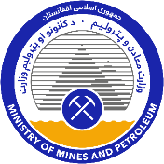
ISLAMIC REPUBLIC OF AFGHANISTAN
MINISTRY OF MINES AND PETROLEUM
TENDER FOR BLOCK S NANGARHAR TALC ACHIN DISTRICT PROJECT
TENDER NOTICE

8 July 2021

Introduction and Project Description
Pursuant to Article 41(2) of the Minerals Law of 2018 published in Official Gazette No. 1315 dated 1398/07/21 (“Minerals Law”), the Ministry of Mines and Petroleum (“Ministry”), hereby announces this tender notice (“Tender Notice”) for the award of a Mining Concession in respect of Block Spin Ghar Nangarhar Talc Project identified by the coordinates and plan in Annexure 1 to this Tender Notice (“Project”).
The Mining Concession will be a two-stage concession that provides for:
- the grant of an Exploration Licence authorizing exploration for Talc in respect of the Project; and
- subject to exploration results and a feasibility study, the right of priority to the grant of an Exploitation Licence authorizing mining and processing.
Details of the Project are included in Annexure 2 of this Tender Notice.
Further details about the Project can be found on the National Procurement Authority website (www.npa.gov.af), Ministry website (www.momp.gov.af), and other websites such as www.dgmarket.com.
Please note that capitalized terms not defined herein have the meanings given to them in the Minerals Law or the Mining Regulations 2019 published in Official Gazette No. (1366) dated 25 January 2020 (“Regulations”).

Expression of Interest and Pre-Qualification
Persons or entities who are interested in this opportunity should complete the Expression of Interest form that is attached to this Tender Notice as Annexure 3 no later than the date specified therein.
The Ministry has published a copy of the Pre-Qualification Questionnaire (“PQQ”) for the Project with this Tender Notice. Interested parties who submit the Expression of Interest form (“Prospective Bidders”) should complete the PQQ according to the instructions included therein and lodge the completed PQQ according to the directions below.
The PQQ must be completed in (i)] English [and (ii) either Dari or Pashto and submitted in hard and soft (e.g., delivered on a flash drive) copy contained in a sealed envelope to Sayed Zabihullah Shadab, Directorate of Large Scale Mines Management, Ministry of Mines and Petroleum, Charayi Abdulhaq (Abdulhaq Circle), Kabul, Afghanistan.
Responses to the PQQ will be due no later than 12 noon (Kabul Local Time) on [8 September 2021].
The Ministry will evaluate responses to the PQQ based on:
- satisfaction of all of the requirements described in the PQQ, including eligibility requirements;
- the technical expertise of the Prospective Bidder and key personnel associated with the Prospective Bidder to conduct exploration in respect of the Project (see Regulations, Article 11(2)1);
- the financial capacity of the Prospective Bidder to conduct exploration of the Project (see Regulations, Article 11(2)1);
- the experience of the Prospective Bidder and key personnel associated with the Prospective Bidder, in the successful delivery on commitments related to community development, local content, environmental management, and health and safety (see Regulations, Article 11(2)3); and
- intent to expend funds in exploration of the Project over the first three year term of the Exploration Licence in excess of [250,000 USD] (see Regulations, Article 11(2)4).

Tender Process
The Ministry will notify Prospective Bidders if they have qualified to participate in the tender process.
Qualified Prospective Bidders must submit a bid document fee to the Ministry in the amount of three hundred thousand (300,000) Afghan Afghani pursuant to Article 12(3) and Schedule 2 of the Regulations no later than 12 noon (Kabul Local Time) on [Ministry will share the exact date with the qualified bidders after the evaluation of PQQ].
Qualified Bidders will also be asked to sign a Non-Disclosure Agreement (which is set out in the PQQ).
Upon payment of the bid document fee and submission of an executed Non-Disclosure Agreement, the Ministry will issue a Request for Proposal (“RFP”) to such qualified Prospective Bidders.
Tender proposals in response to the RFP will be due no later than 12 noon (Kabul Local Time) on [30 October 2021].
A bid bond is required and the amount of such bid bond will be stated in the RFP. The bid bond shall be in the form of bonds or securities provided by an established bank or financial institution which is registered in accordance with applicable laws, and is acceptable to the Ministry. Subject to Article 17(3) of the Regulations and pursuant to Article 17(4) of the Regulations, the bid bond will be returned to the appropriate bidder within 10 working days of (i) execution of the Mining Concession by that bidder; (ii) execution of a Mining Concession by another bidder; or (iii) termination of the bidding process without award of a Mining Concession.
The bidding process for the Project will be administered by the Directorate of Large Scale Mines Management, which is responsible for the administration of tendering processes for large scale mining projects in accordance with the Minerals Law and Regulations.
Annexure 1 – Project Area

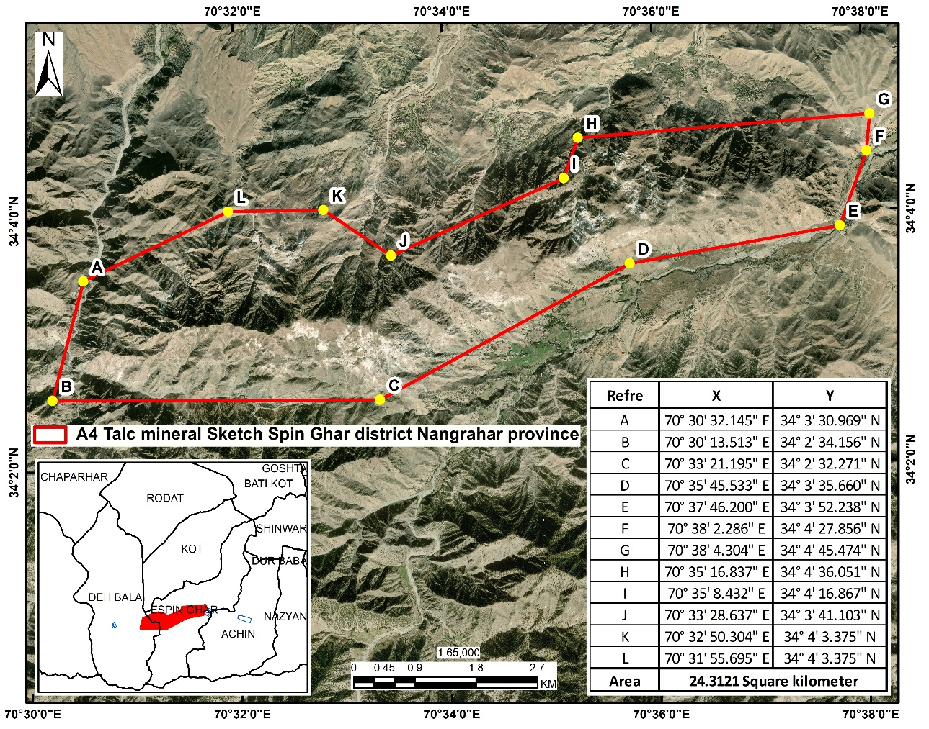

Annexure 2 - Project Description
The planned talc areas are located in Nangarhar province, which is one of the eastern populated provinces. It has a little topographical difference in height. The Talc area Spin Ghar block is located south of Nangarhar province, which is 42 km away from the center of the province, 8.9 km from Haska-meena district, 8 km from the center of Achin district, and 9.4 km from the Durand proposed line. The area is 24.3 square kilometers.
According to the tectonic map of Afghanistan, the intended talc area is located in the Jalalabad tectonic block. Therefore, tectonic activities in the mentioned area have caused the formation of large and small regional and local belts, which have been formed as a result of metamorphism and metasomatism. The metamorphic formation of the region belongs to the Middle and Upper Proterozoic, which in the deposit area consists of dolomitic marbles.
There are non-asphalted subways in the mining area, built by locals to transport industrial materials and talc ores.
The distance of the Talc area from the public road is about 20 km. There are water flows in the sub-valleys, which are mainly seasonal. In the seasons when there is a lot of rain (spring and winter), the amount of water in the region is abundant and they can be stored and used by constructing a temporary dam in the waterless (dry) seasons.
Main agricultural crops are different kinds of ostriches, olives, vegetables and various legumes and
Nangarhar province has a humid and hot climate that the rainfall during the year is better than other provinces of the country. The day-night temperature varies from -5c ° to + 40c ° during the year and mainly has very hot summer, partly with humid weather.
Main agricultural crops are different kinds of ostriches, olives, vegetables and various legumes and beans. Most of the locals are engaged in agriculture and livestock and a small number are engaged in business activities.
beans. Most of the locals are engaged in agriculture and livestock and a small number are engaged in business activities.
Based on global experience, the exploitation of talc projects has high effects on the physical elements (air, surface and ground waters, and lithosphere) and biological elements (humans, plants, and animals) of the environment. Environmental protection and rehabilitation of the site according to mining laws and the environment and the relevant regulations and procedures of the country considering the site situation are mandatory by the contractor company that obtains the mining contract. Therefore, the bidding companies should carefully plan and implement the management and assessment of adverse environmental and social impacts (ESIA), according to the law, regulations and procedures of the Ministry of Mines and the National Environmental Protection Agency (NEPA).
Annexure 3 – Expression of Interest Form
ISLAMIC REPUBLIC OF AFGHANISTAN
MINISTRY OF MINES AND PETROLEUM
TENDER FOR BLOCK S NANGARHAR TALC ACHIN DISTRICT PROJECT
EXPRESSION OF INTEREST FORM

The Ministry of Mines and Petroleum (“Ministry”), has announced a Tender Notice dated [8 July 2021] (“Tender Notice”) for the award of a Mining Concession in respect of Spin Ghar Block Talc project as described in more detail in the Tender Notice (“Project”).
This Expression of Interest form (“EoI Form”) is the form that needs to be completed by persons or entities who wish to express their interest to undertake the Project.
Further details of the Project can be found in the Tender Notice and on the National Procurement Authority website (www.npa.gov.af), Ministry website (www.momp.gov.af), and other websites such as www.dgmarket.com.
This EoI Form must be completed in (i) English or (ii) either Dari or Pashto and submitted by email to [Recipient: Sayed Zabihullah Shadab Email: largescalemining@momp.gov.af], Directorate of Large Scale Mines Management, Ministry of Mines and Petroleum, Charayi Abdulhaq (Abdulhaq Circle), Kabul, Afghanistan.
For more information, contact [largescalemining@momp.gov.af/ 0705124518].
The completed EoI Form must be received by 12:00 noon Kabul local time on [8 August 2021].

INTERESTED PARTY INFORMATION
Name:

Legal status (Please identify the interested party as a natural person, public limited company, private limited company, partnership, consortium, joint venture, special purpose vehicle, or other arrangement, as applicable):

Registered address(es):

Registration number(s) (if applicable):

Country of incorporation/registration (If completing this form on behalf of an entity, identify the country under which laws the entity (and each member entity, if applicable) is organized):

DESIGNATED POINT OF CONTACT INFORMATION
Name:

Title:

E-Mail address:

Telephone number:

Postal address:

By signing below, I affirm that (insert interested party’s name) is interested in participating in the tender process in respect of the Project and requests a copy of the Pre-Qualification Questionnaire for the tender process in respect of the Project. I also affirm that I am duly authorized to sign this EoI Form on behalf of (insert interested party’s name) .

By:____________________________
Name:__________________________
Title:____________________________

Company stamp (if applicable):

